SELECTOR SWITCH

SEIMENS

1. SELECTOR SWITCH (2 POSITION)

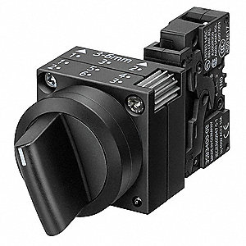

1. SELECTOR SWITCH (3 POSITION)

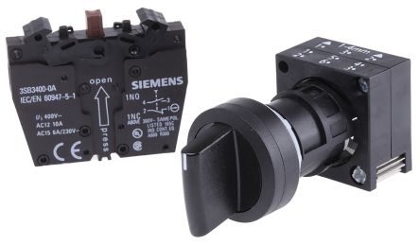

1. ILLUMINATED SELECTOR SWITCH

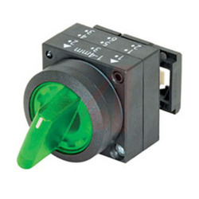

1. KEY SELECTOR SWITCH

